|  |  |
| --- | --- |
| **Reading Time** | 10 mins |
| **Difficulty** | Beginner |

|  |
| --- |
| **Sections** |
| The Arduino Language |
| What is a library? |
| Anatomy of an Arduino Sketch |

**The Arduino environment (H1)**

**If you want to get set up and running, check out our the getting started guide. Let’s learn about the Arduino environment**

**The Arduino programming language is what we use to program QuadBot. Arduino is a huge platform with a large user base and lots of example code. Perfect for us.**

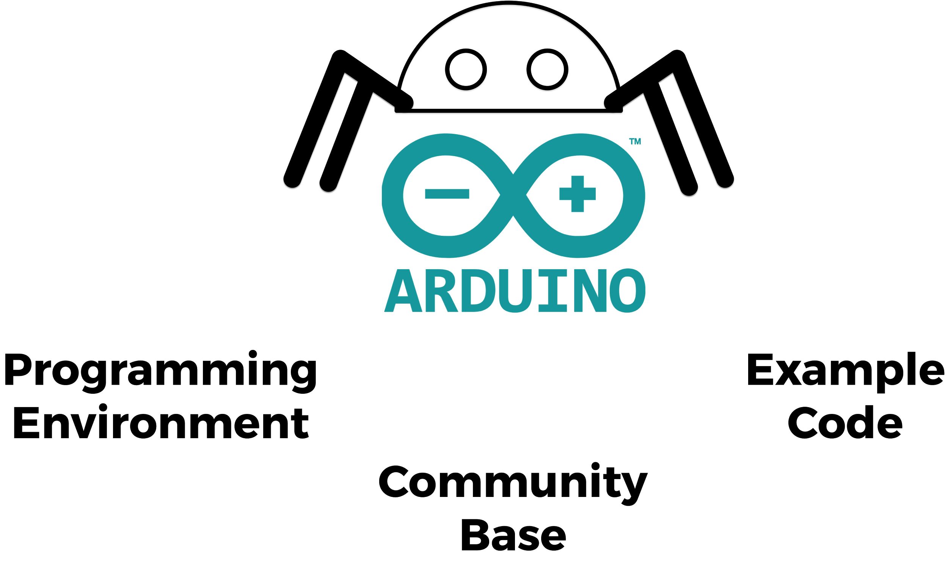

**But what actually is the Arduino language? Let’s take a look.**

**The Arduino Language**

**Arduino is based on the C++ language, which has been around since 1983. C++ is used with microcontrollers but can be a bit complicated.**

**The Arduino language makes C++ a lot easier because Arduino has loads of software libraries containing pre-written functions. This means if you want to perform a specific operation it’s likely there’s a function already existing for you.**

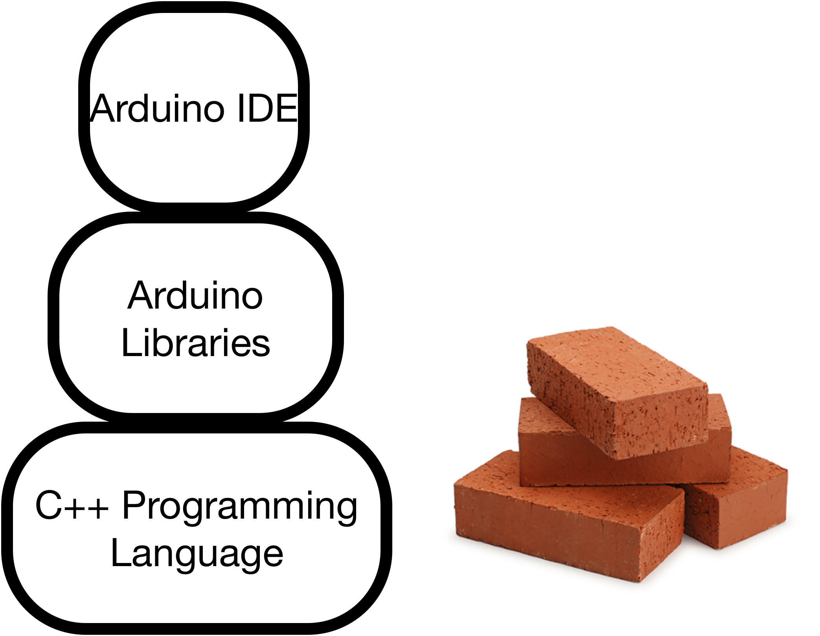

**What is a library? (H1)**

**A software library is basically a bit list of functions written by someone else. They’ve done all the hard work of creating the function and getting it work, so that we can use the function in our programs. Why? Because coders are pretty awesome people.**

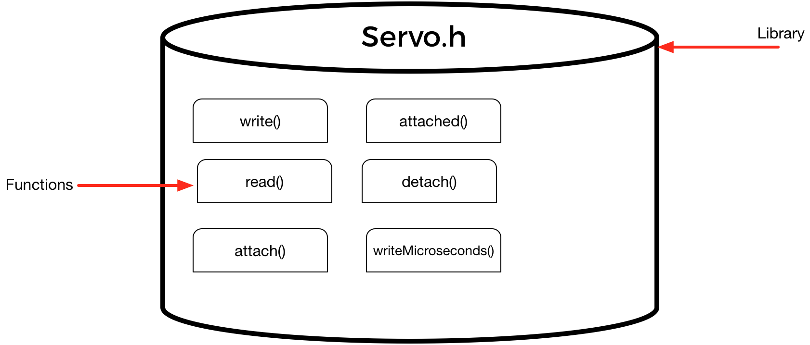

**There’s LOTS of different libraries for arduino, some are official and well documented, others are unofficial and bit hacky.**

**To include a library in our code, we use the following statement at the top of our program…**

#include <myLibrary.h>

**Anatomy of an Arduino Sketch (H1)**

**All Arduino sketches consist of two parts, setup() and loop(). The setup() runs once at the start, the loop() runs continuously.**

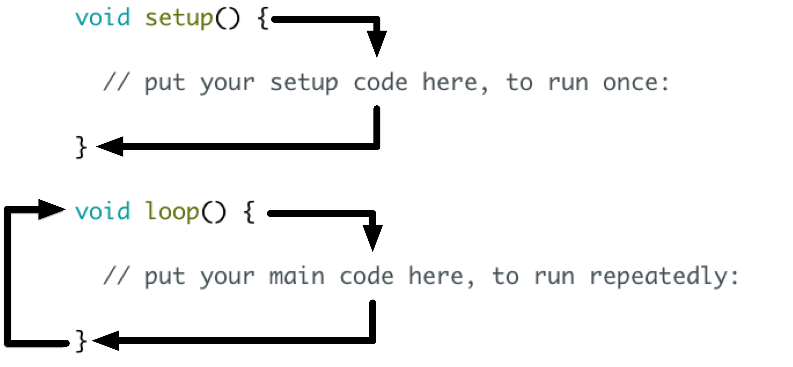

**You’ll use the setup() for things like setting up pins as inputs or outputs.**

**You’ll use the loop() to run your main code.**

**Here’s an Arduino sketch in all its glory.**

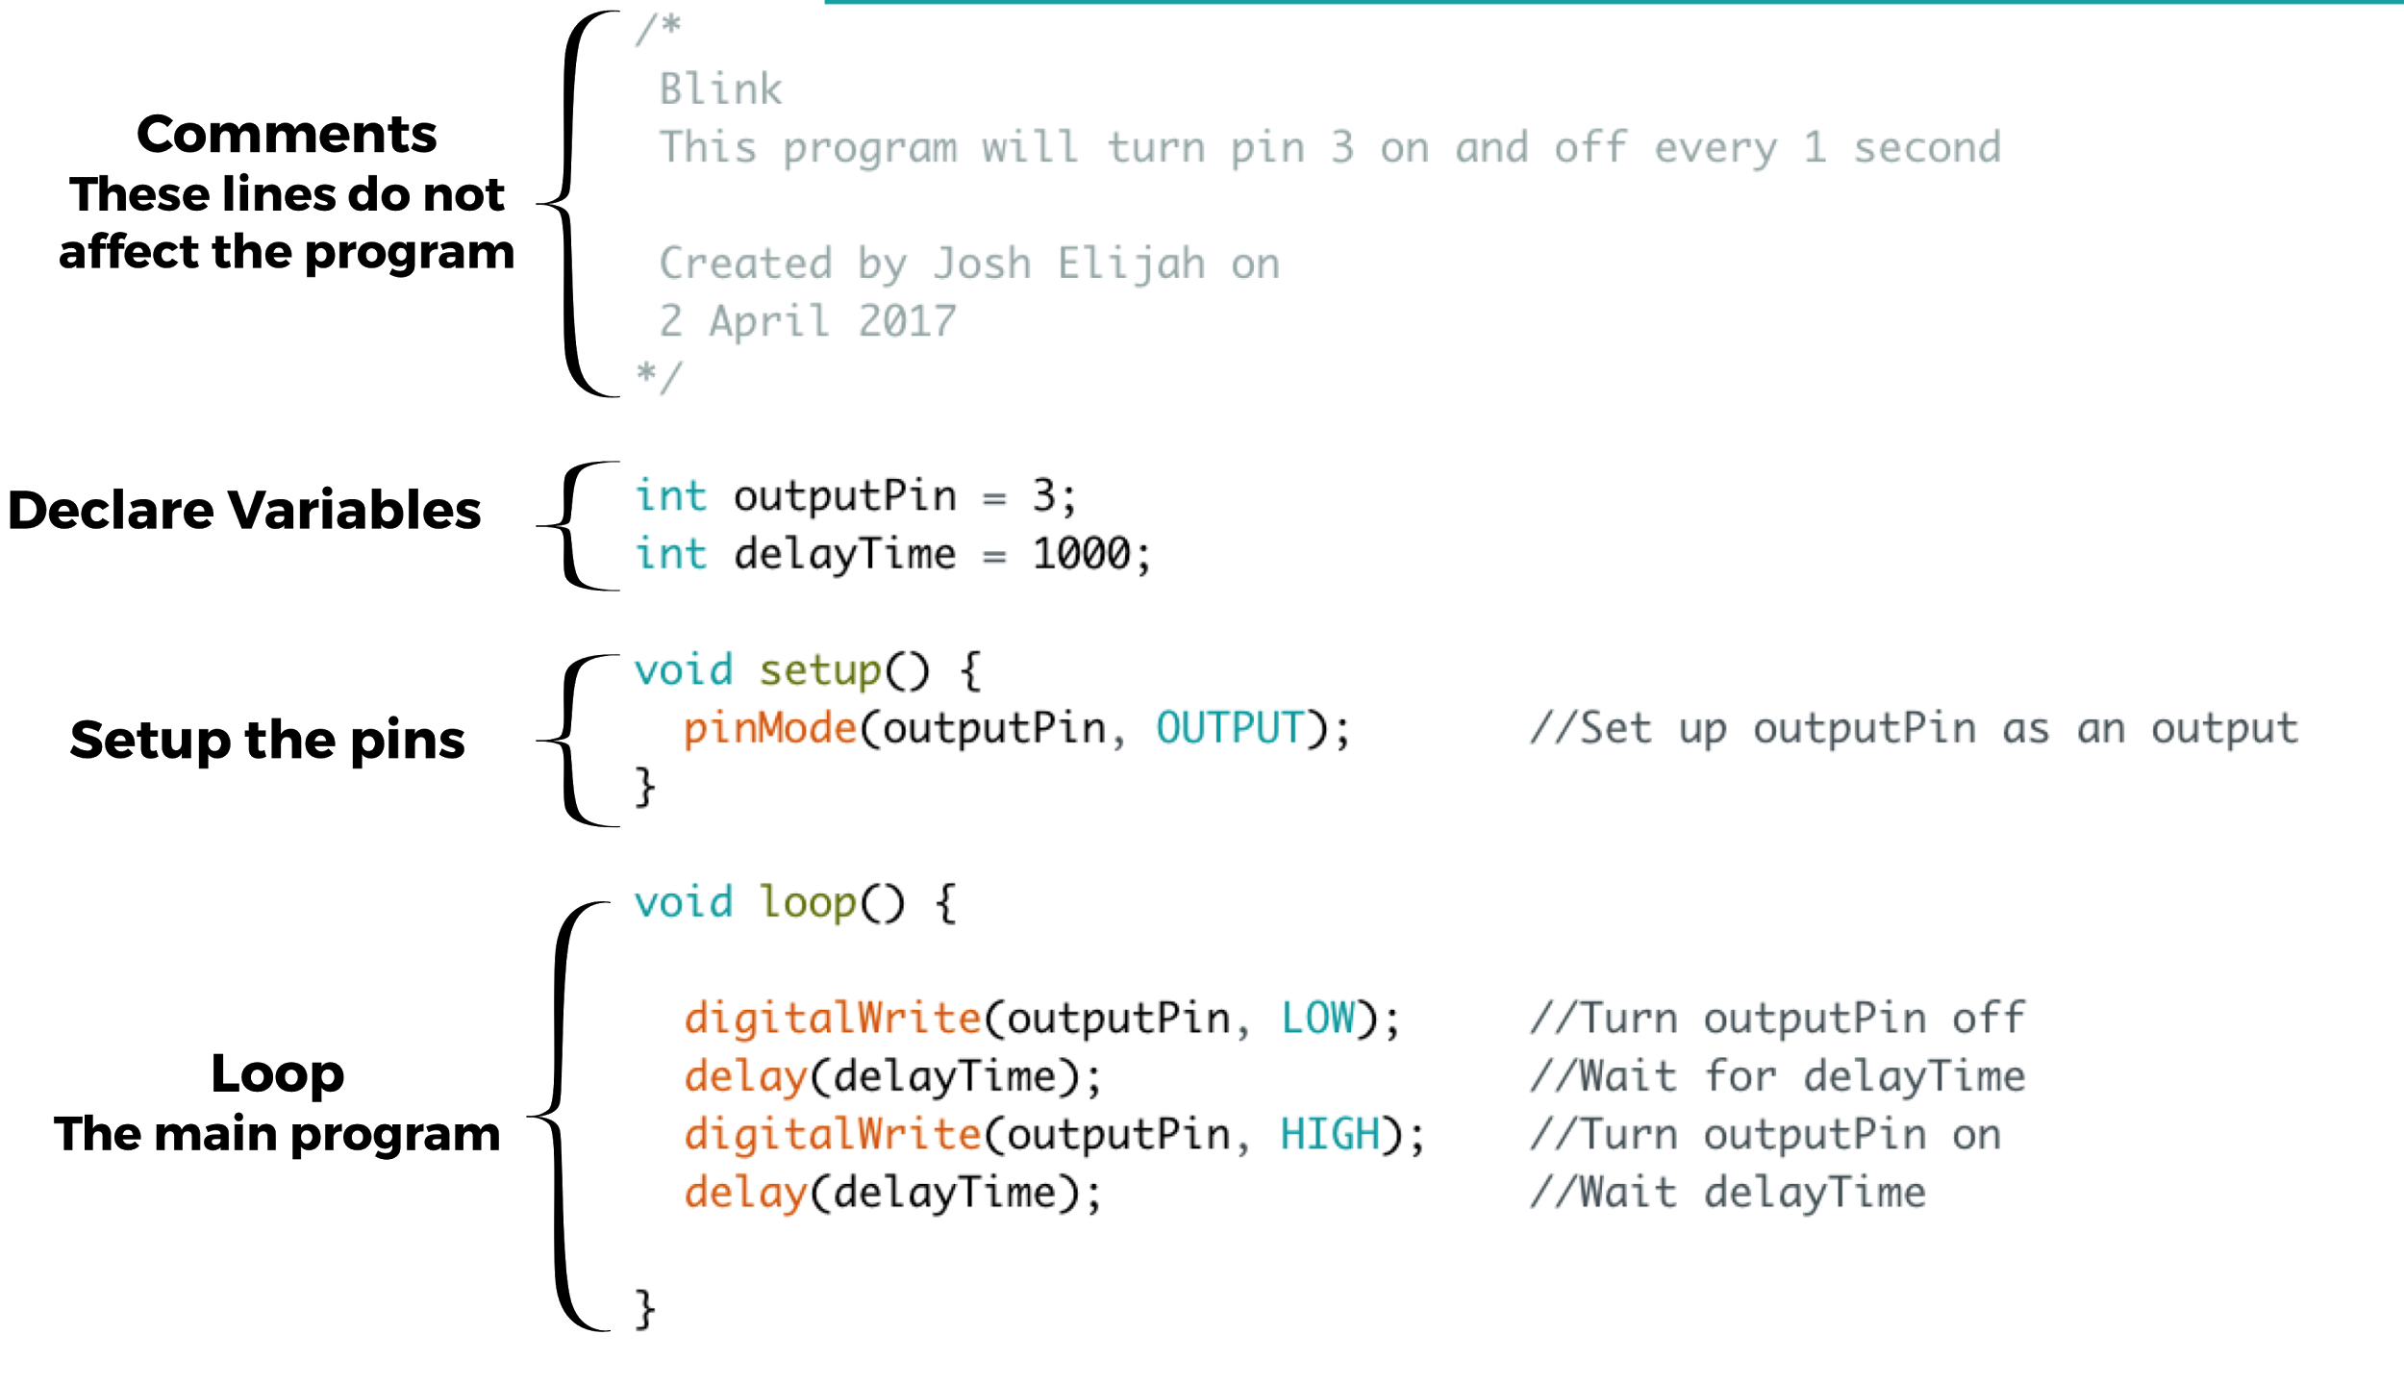

**Comments: These do not affect the program, they are there to help humans understand the code.**

**Declare Variables: We declare any variables here at the start of the program.**

**Setup: We setup the pin as an output. We only need to do this once at the start, so it goes in setup().**

**Loop: Inside here is the code we want to repeat, turning the pin on and off.**

**Conclusion (H1)**